Java ArrayList

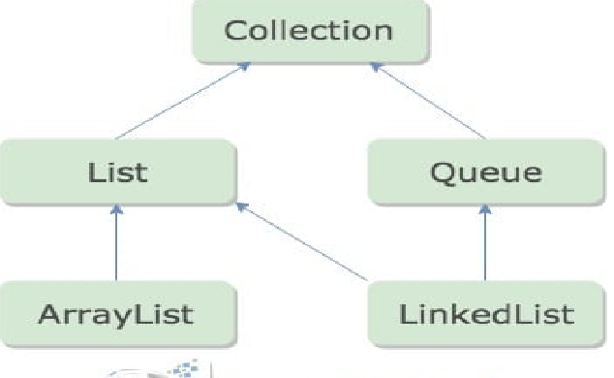

The ArrayList class is a resizable array, which can be found in the java.util package.

The difference between a built-in array and an ArrayList in Java, is that the size of an array cannot be modified (if you want to add or remove elements to/from an array, you have to create a new one). While elements can be added and removed from an ArrayList whenever you want. The syntax is also slightly different:

Example

Create an ArrayList object called cars that will store strings:

import java.util.ArrayList; // import the ArrayList class

ArrayList<String> cars = new ArrayList<String>();

/\*Create an ArrayList object If you don't know what a package is, read our Java Packages Tutorial.\*/

Add Items

The ArrayList class has many useful methods. For example, to add elements to the ArrayList, use the add() method:

Example

import java.util.ArrayList;

public class MyClass {

public static void main(String[] args) {

ArrayList<String> cars = new ArrayList<String>();

cars.add("Volvo");

cars.add("BMW");

cars.add("Ford");

cars.add("Mazda");

System.out.println(cars);

}

}

Access an Item

To access an element in the ArrayList, use the get() method and refer to the index number:

Example

cars.get(0);

Remember: Array indexes start with 0: [0] is the first element. [1] is the second element, etc.

Change an Item

To modify an element, use the set() method and refer to the index number:

Example

cars.set(0, "Opel");

Remove an Item

To remove an element, use the remove() method and refer to the index number:

Example

cars.remove(0);

To remove all the elements in the ArrayList, use the clear() method:

Example

cars.clear();

ArrayList Size

To find out how many elements an ArrayList have, use the size method:

Example

cars.size();

Loop Through an ArrayList

Loop through the elements of an ArrayList with a for loop, and use the size() method to specify how many times the loop should run:

Example

public class MyClass {

public static void main(String[] args) {

ArrayList<String> cars = new ArrayList<String>();

cars.add("Volvo");

cars.add("BMW");

cars.add("Ford");

cars.add("Mazda");

for (int i = 0; i < cars.size(); i++) {

System.out.println(cars.get(i));

}

}

}

You can also loop through an ArrayList with the for-each loop:

Example

public class MyClass {

public static void main(String[] args) {

ArrayList<String> cars = new ArrayList<String>();

cars.add("Volvo");

cars.add("BMW");

cars.add("Ford");

cars.add("Mazda");

for (String i : cars) {

System.out.println(i);

}

}

}

Other Types

Elements in an ArrayList are actually objects. In the examples above, we created elements (objects) of type "String". Remember that a String in Java is an object (not a primitive type). To use other types, such as int, you must specify an equivalent wrapper class: Integer. For other primitive types, use: Boolean for boolean, Character for char, Double for double, etc:

Example

Create an ArrayList to store numbers (add elements of type Integer):

import java.util.ArrayList;

public class MyClass {

public static void main(String[] args) {

ArrayList<Integer> myNumbers = new ArrayList<Integer>();

myNumbers.add(10);

myNumbers.add(15);

myNumbers.add(20);

myNumbers.add(25);

for (int i : myNumbers) {

System.out.println(i);

}

}

}

Sort an ArrayList

Another useful class in the java.util package is the Collections class, which include the sort() method for sorting lists alphabetically or numerically:

Example

Sort an ArrayList of Strings:

import java.util.ArrayList;

import java.util.Collections; // Import the Collections class

public class MyClass {

public static void main(String[] args) {

ArrayList<String> cars = new ArrayList<String>();

cars.add("Volvo");

cars.add("BMW");

cars.add("Ford");

cars.add("Mazda");

Collections.sort(cars); // Sort cars

for (String i : cars) {

System.out.println(i);

}

}

}

Example

Sort an ArrayList of Integers:

import java.util.ArrayList;

import java.util.Collections; // Import the Collections class

public class MyClass {

public static void main(String[] args) {

ArrayList<Integer> myNumbers = new ArrayList<Integer>();

myNumbers.add(33);

myNumbers.add(15);

myNumbers.add(20);

myNumbers.add(34);

myNumbers.add(8);

myNumbers.add(12);

Collections.sort(myNumbers); // Sort myNumbers

for (int i : myNumbers) {

System.out.println(i);

}

}

}